**OOPS MINI PROJECT-VOL-1**

**BATCH-2 TEAM-4**

**TEAM MEMBERS:**

1. **HARI SHANKAR M**
2. **HIMAL P S G**
3. **BARATH VAJ T.K.S**
4. **RAJESH C**

**PROJECT TITLE: “EBOOKSHOP-MANAGEMENT”**

**ABSTRACT:**

This project is based on the management of ebookshop. This mainly focus on the credentials stored for accessing the bookshop and the admin,user details into a database. This helps the user to access the book availability details from the shop,the cost of the book,the author of the book, and the quantity of the available stock.

**FRONT-END:**

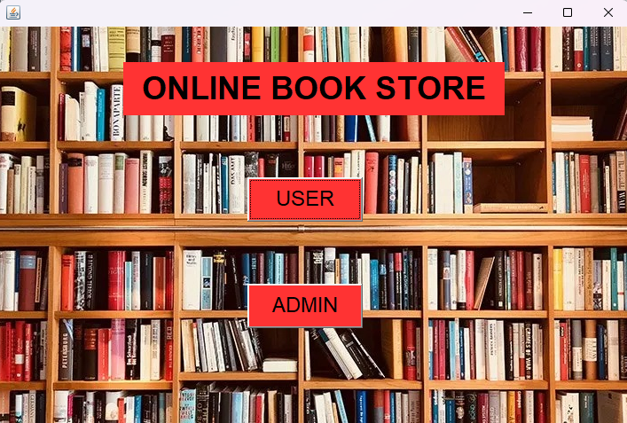

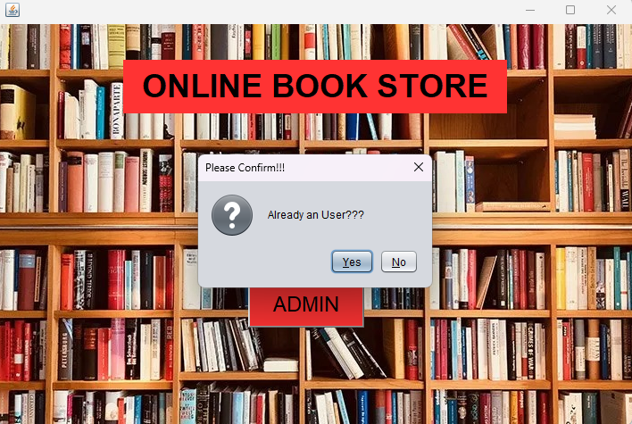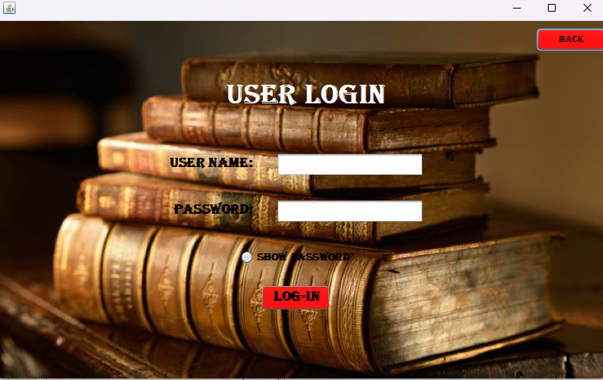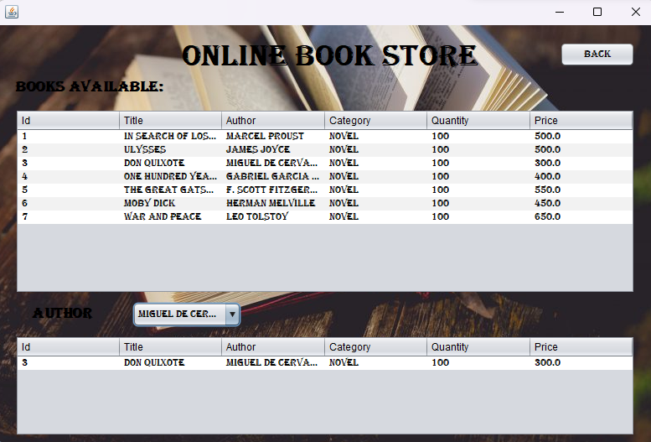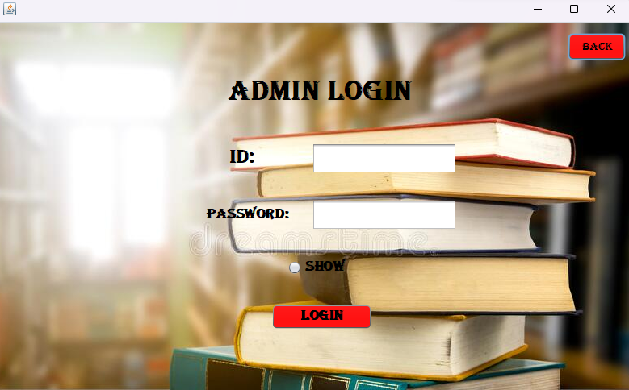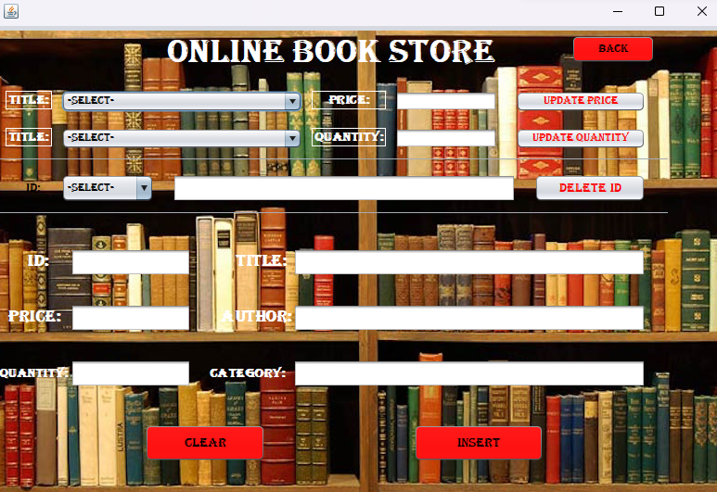

**DATABASE DESIGN:**

